**UHO**

United Health Organization

**Integration Technical Design Document**

**uhub-sapi technical design**

|  |  |  |
| --- | --- | --- |
| **Project/Service Identifier:** |  | Uhub system API |
| **Prepared By:** | Chinna Reddy |
| **Document Version:** | Version 1.0.0 |
| **Published Date:** | 2021/08/12 |

**Revision History**

|  |  |  |  |
| --- | --- | --- | --- |
| **Version Number** | **Revision Date** | **Summary of Changes** | **Modified by** |
| 0.1 | *2021/08/12* | Initial document created | *Chinna Reddy* |
|  |  |  |  |
|  |  |  |  |
|  |  |  |  |
|  |  |  |  |

**Contributors**

| **Name** | **Title** |
| --- | --- |
| *Chinna Reddy* | *Mulesoft Technical Architect* |
|  |  |
|  |  |
|  |  |

**Distribution & Reviewers**

| **Name** | **Title** |
| --- | --- |
| *Technical Reviewer* | *TBD* |
| *QA Reviewer* | *TBD* |
| *Architecture Reviewer* | *TBD* |
| *PM* | *TBD* |

**Approvals**

|  |  |  |  |
| --- | --- | --- | --- |
| **Interface ID** | **Interface Name** | **Approval Given On** | **Approver(s)** |
| **1** | **register-covid-case** | **TBD** | **TBD** |
| **2** | **update-covid-case** | **TBD** | **TBD** |
| **3** | **get-covid-case-by-ssn** | **TBD** | **TBD** |
| **4** | **get-covid-reports** | **TBD** | **TBD** |
|  |  |  |  |
|  |  |  |  |
|  |  |  |  |

**Table of Contents**

1 Introduction 1

1.1 Document Overview 1

1.1.1 Intended Audience 1

1.1.2 Structure 1

1.1.1 Related Documents 1

2 Technical Architecture 2

3 Services/APIs High level Specification 3

3.1 register-covid-case : https://uho-{env}-uhub-sapi/v1/covid-cases 3

3.1.1 Input and Output Definitions of API 3

3.1.2 Mapping 4

3.1.3 Consumers 4

3.1.4 Technical details 4

3.1.5 Non Functional 4

3.1.6 Error Handling 5

3.1.7 Integration test cases 5

3.1.8 API Endpoint Details 5

3.2 update-covid-case : https://uho-{env}-uhub-sapi/v1/covid-cases 5

3.2.1 Input and Output Definitions of API 6

3.2.2 Mapping 7

3.2.3 Consumers 7

3.2.4 Technical details 7

3.2.5 Non Functional 7

3.2.6 Error Handling 8

3.2.7 Integration test cases 8

3.2.8 API Endpoint Details 8

3.3 get-covid-cases-by-uid : https://uho-{env}-uhub-sapi/v1/covid-cases/{ssn} 8

3.3.1 Input and Output Definitions of API 9

3.3.2 Database & table details 10

3.3.3 Consumers 10

3.3.4 Technical details 10

3.3.5 Non Functional 10

3.3.6 Error Handling 11

3.3.7 Integration test cases 11

3.3.8 API Endpoint Details 11

3.4 get-covid-reports : https://uho-{env}-uhub-sapi/v1/covid-reports?state=texas 11

3.4.1 Input and Output Definitions of API 12

3.4.2 Database & table details 12

3.4.3 Consumers 13

3.4.4 Technical details 13

3.4.5 Non Functional 13

3.4.6 Error Handling 13

3.4.7 Integration test cases 14

3.4.8 API Endpoint Details 14

4 API Policies, Access and Network Security - TBD 15

5 Open Issues 16

6 Appendix A – Interface details 17

# Introduction

## Document Overview

### Intended Audience

This document is intended to be used by the integration developers, Integration support team, architects, and testers who will be designing, implementing, and maintaining these middleware services. This document is not intended to be used by the API consumers; API documentation is provided on the Anypoint platform.

### Structure

This document contains an overview and depiction of all the services. Document includes detailed designs for each service, including intended API consumers, business rules, technical considerations, and result codes.

### Related Documents

The following list provides links to related documents:

|  |  |  |
| --- | --- | --- |
| Document | Intended Use | Share point Link |
| Solution Architecture Document |  |  |
| Data Mapping document |  |  |

# Technical Architecture

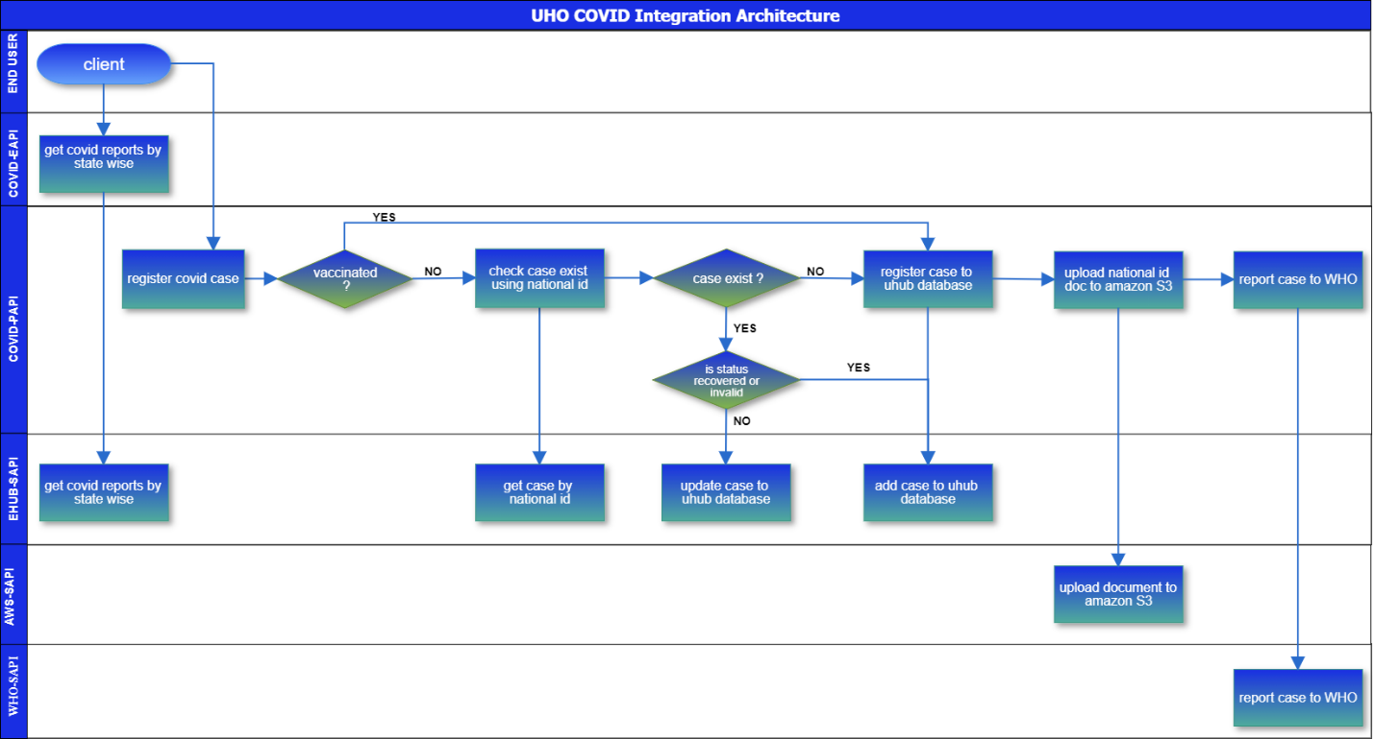

1. Process API or experience API calls uhub-sapi get-covid-case-by-national-id service to check covid case exist already.
2. If case doesn’t exist then process API calls register-covid-case to add case database.
3. If the case already exist then calls update-covid-case to update the case.
4. The process API or experience API calls get-covid-reports service to get covid report by state or for all states.

# Services/APIs High level Specification

## register-covid-case : https://uho-{env}-uhub-sapi/covid/v1/cases

This is a POST based API allows COVID case JSON payload as input then inserts to uhub database and responds back 201, CREATED. On failure the API will respond back corresponding error code and message along with description.

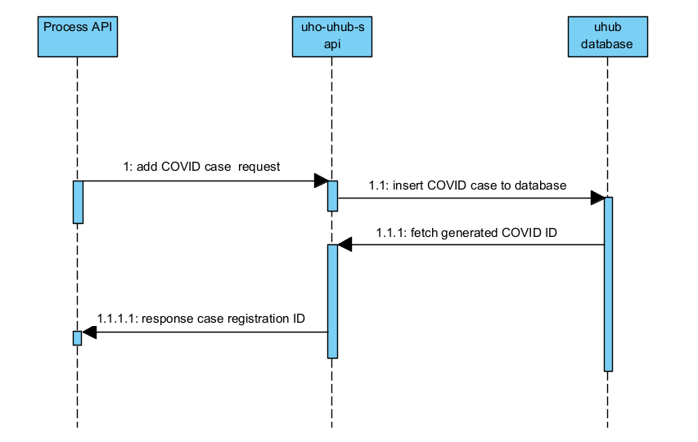

1. The process API’s consumes uho-uhub-sapi.
   1. The uho-uhub-sapi inserts case to database.
      1. The database responds back generated case Id to process API.

1.1.1.1 The process API responds back registration id to end user.

### Input and Output Definitions of API

**Input:** {

   "source":"Hospital1",

   "caseType":"positive",

   "firstName":"John",

   "lastName":"Nixon",

   "phone":"541-754-3010",

   "email":"john@gmail.com",

   "dateOfBirth":"1989-04-26",

   "nationalID":"209-49-6193",

   "nationalIDType":"SSN",

   "address":{

      "streetAddress":"1600 Pennsylvania Avenue NW",

      "city":"Washington",

      "state":"DC",

      "postal":"20500",

      "country":"USA"

   }

}

**Output: 201, Created**

{

       "caseID": "3673673"

}

### Mapping



### Consumers

|  |  |  |
| --- | --- | --- |
| API Consumer | Description | |
| Experience API’s | | Experience API’s consumes uhub-sapi services to register as case or to fetch COVID cases details. |
| Other UHO applications | | UHO applications can consume uhub-sapi services on requirement since uhub-sapi enabled as utility API in UHO application network. |

### Technical details

|  |  |
| --- | --- |
| API Name | uhub-sapi |
| Business Requirements | As mentioned in integration solution document |
| API Communication Type | REST |
| Interface Pattern | Request/Reply |
| Interface Definitions | RAML API Specification |
| Sample Request | JSON(Section 3.1.1) |
| Sample Response | JSON(Section 3.1.1) |

### Non Functional

|  |  |
| --- | --- |
| Post Execution Notification Details | Data-Related Failures Handling:  Currently all the errors will be logged into logs with log4j.  Consumer API is responsible to log about error details.  Can be visible in runtime manager.  Technical Errors Handling:  Currently all the errors will be logged into logs with log4j.  Consumer API is responsible to log about error details.  Can be visible in runtime manager. |
| Process Log Audit Details | Audit & Logging:  Created Logs for the following   * Request message at entry point * Request message at system call entry point * Request message at system call entry point * Request completed |

### Error Handling

|  |  |  |
| --- | --- | --- |
| No. | Type of Exception | Exception Handling |
| 1 | Any technical issue | * API shall respond corresponding response message. * API will record the error in logs. * Runtime manager notifications will be configured - TBD * Application Administrative team will be notified using an email notification service- TBD |

### Integration test cases

| **Description** | **Result** |
| --- | --- |
| Successful case registration | 201 - Created |
| System connectivity failure (Database is down) | 503 - The (upstream) service is temporarily not available |
| Invalid JSON payload request | 400 – Bad request |
| Internal server error | 500 – Internal server error |
| API Kit Router errors | Global errors |

### API Endpoint Details

| **Requirement** | **Method** | **Details** |
| --- | --- | --- |
| **Development** | POST | <https://uho-dev-uhub-sapi/covid/v1/>cases |
| **Test** | POST | <https://uho-test-uhub-sapi/covid/v1/>cases |
| **UAT** | POST | <https://uho-uat-uhub-sapi/covid/v1/>cases |
| **Production** | POST | <https://uho-prod-uhub-sapi/covid/v1/>cases |

## update-covid-case : https://uho-{env}-uhub-sapi/covid/v1/cases

This is a PUT based API allows COVID case JSON payload as input then updates to uhub database and responds back 200, OK. On failure the API will respond back corresponding error code and message along with description.

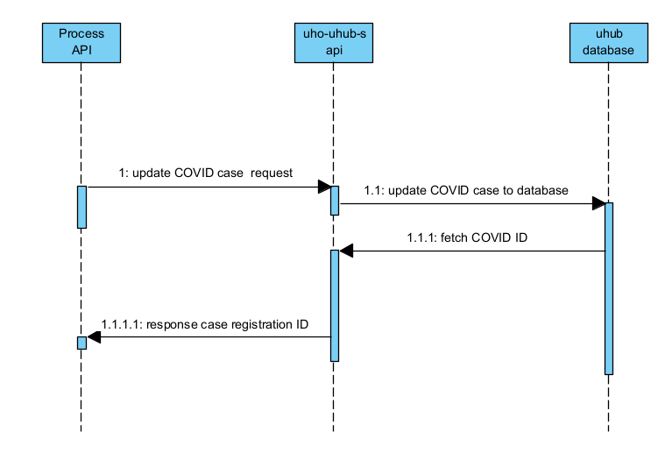

1. The process API’s consumes uho-uhub-sapi.
   1. The uho-uhub-sapi updates case to database.
      1. The database responds back existing case Id to process API.
         1. The process API responds back registration id to end user.

### Input and Output Definitions of API

**Input:**

{

   "source":"Hospital1",

   "caseType":"positive",

   "firstName":"John",

   "lastName":"Nixon",

   "phone":"541-754-3010",

   "email":"john@gmail.com",

   "dateOfBirth":"1989-04-26",

   "nationalID":"209-49-6193",

   "nationalIDType":"SSN",

   "address":{

      "streetAddress":"1600 Pennsylvania Avenue NW",

      "city":"Washington",

      "state":"DC",

      "postal":"20500",

      "country":"USA"

   }

}

**Output: 200, success**

{

       "caseID": "3673673"

}

### Mapping



### Consumers

|  |  |  |
| --- | --- | --- |
| API Consumer | Description | |
| Experience API’s | | Experience API’s consumes uhub-sapi services to register as case or to fetch COVID cases details. |
| Other UHO applications | | UHO applications can consume uhub-sapi services on requirement since uhub-sapi enabled as utility API in UHO application network. |

### Technical details

|  |  |
| --- | --- |
| API Name | uhub-sapi |
| Business Requirements | As mentioned in integration solution document |
| API Communication Type | REST |
| Interface Pattern | Request/Reply |
| Interface Definitions | RAML API Specification |
| Sample Request | JSON(Section 3.2.1) |
| Sample Response | JSON(Section 3.2.1) |

### Non Functional

|  |  |
| --- | --- |
| Post Execution Notification Details | Data-Related Failures Handling:  Currently all the errors will be logged into logs with log4j.  Consumer API is responsible to log about error details.  Can be visible in runtime manager.  Technical Errors Handling:  Currently all the errors will be logged into logs with log4j.  Consumer API is responsible to log about error details.  Can be visible in runtime manager. |
| Process Log Audit Details | Audit & Logging:  Created Logs for the following   * Request message at entry point * Request message at system call entry point * Request message at system call entry point * Request completed |

### Error Handling

|  |  |  |
| --- | --- | --- |
| No. | Type of Exception | Exception Handling |
| 1 | Any technical issue | * API shall respond corresponding response message. * API will record the error in logs. * Runtime manager notifications will be configured - TBD * Application Administrative team will be notified using an email notification service- TBD |

### Integration test cases

| **Description** | **Result** |
| --- | --- |
| Successful case registration | 200 - Success |
| System connectivity failure (Database is down) | 503 - The (upstream) service is temporarily not available |
| Invalid JSON payload request | 400 – Bad request |
| Internal server error | 500 – Internal server error |
| API Kit Router errors | Global errors |

### API Endpoint Details

| **Requirement** | **Method** | **Details** |
| --- | --- | --- |
| **Development** | UPDATE | <https://uho-dev-uhub-sapi/covid/v1/>cases |
| **Test** | UPDATE | <https://uho-test-uhub-sapi/covid/v1/>cases |
| **UAT** | UPDATE | <https://uho-uat-uhub-sapi/covid/v1/>cases |
| **Production** | UPDATE | <https://uho-prod-uhub-sapi/covid/v1/>cases |

## get-covid-cases-by-national-id: https://uho-{env}-uhub-sapi/covid/v1/cases/{nationalID}

This is a GET based API used to respond COVID case details by nationalID as URI parameter and responds back 200, SUCCESS with covid case payload. On failure the API will respond back corresponding error code and message along with description.

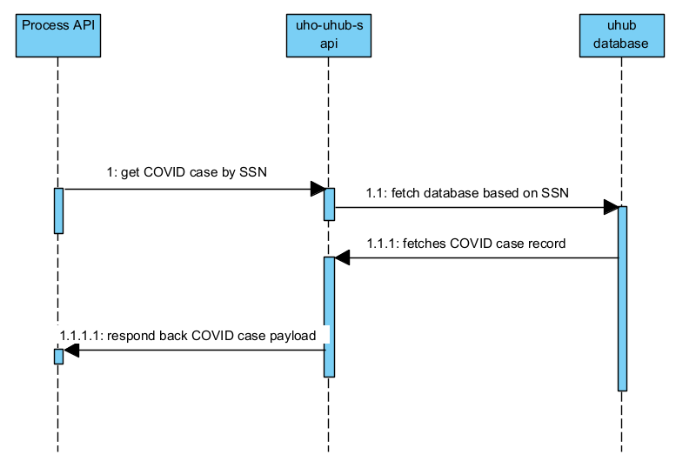

1. The process API’s consumes uho-uhub-sapi.
   1. The uho-uhub-sapi inserts case to database.
      1. The database responds back generated case Id to process API.
         1. The process API responds back registration id to end user.

### Input and Output Definitions of API

**Input: /209-49-6193**

**Output: 200, OK**

[

   {

      "source":"Hospital1",

      "caseID":"456464",

      "caseType":"positive",

      "firstName":"John",

      "lastName":"Nixon",

      "phone":"541-754-3010",

      "email":"john@gmail.com",

      "dateOfBirth":"1989-04-26",

      "nationalID":"209-49-6193",

      "nationalIDType":"SSN",

      "address":{

         "streetAddress":"1600 Pennsylvania Avenue NW",

         "city":"Washington",

         "state":"DC",

         "postal":"20500",

         "country":"USA"

      },

      "createDate":"2021-05-03",

      "updateDate":"2021-05-03"

   },

   {

      "source":"Hospital1",

      "caseID":"528293",

      "caseType":"negative",

      "firstName":"John",

      "lastName":"Nixon",

      "phone":"541-754-3010",

      "email":"john@gmail.com",

      "dateOfBirth":"1989-04-26",

      "nationalID":"209-49-6193",

      "nationalIDType":"SSN",

      "address":{

         "streetAddress":"1600 Pennsylvania Avenue NW",

         "city":"Washington",

         "state":"DC",

         "postal":"20500",

         "country":"USA"

      },

      "createDate":"2020-12-14",

      "updateDate":"2020-12-14"

   }

]

### Mapping



### Consumers

|  |  |  |
| --- | --- | --- |
| API Consumer | Description | |
| Experience API’s | | Experience API’s consumes uhub-sapi services to register as case or to fetch COVID cases details. |
| Other UHO applications | | UHO applications can consume uhub-sapi services on requirement since uhub-sapi enabled as utility API in UHO application network. |

### Technical details

|  |  |
| --- | --- |
| API Name | uhub-sapi |
| Business Requirements | As mentioned in integration solution document |
| API Communication Type | REST |
| Interface Pattern | Request/Reply |
| Interface Definitions | RAML API Specification |
| Sample Request | JSON(Section 3.3.1) |
| Sample Response | JSON(Section 3.3.2) |

### Non Functional

|  |  |
| --- | --- |
| Post Execution Notification Details | Data-Related Failures Handling:  Currently all the errors will be logged into logs with log4j.  Consumer API is responsible to log about error details.  Can be visible in runtime manager.  Technical Errors Handling:  Currently all the errors will be logged into logs with log4j.  Consumer API is responsible to log about error details.  Can be visible in runtime manager. |
| Process Log Audit Details | Audit & Logging:  Created Logs for the following   * Request message at entry point * Request message at system call entry point * Request message at system call entry point * Request completed |

### Error Handling

|  |  |  |
| --- | --- | --- |
| No. | Type of Exception | Exception Handling |
| 1 | Any technical issue | * API shall respond corresponding response message. * API will record the error in logs. * Runtime manager notifications will be configured - TBD * Application Administrative team will be notified using an email notification service- TBD |

### Integration test cases

| **Description** | **Result** |
| --- | --- |
| Successful cases | 200 - Success |
| National ID not found | 404 – Not Found |
| System connectivity failure (Database is down) | 503 - The (upstream) service is temporarily not available |
| Internal server error | 500 – Internal server error |
| API Kit Router errors | Global errors |

### API Endpoint Details

| **Requirement** | **Method** | **Details** |
| --- | --- | --- |
| **Development** | GET | <https://uho-dev-uhub-sapi/covid/v1/>cases/{nationalID} |
| **Test** | GET | <https://uho-test-uhub-sapi/covid/v1/>cases/{nationalID} |
| **UAT** | GET | <https://uho-uat-uhub-sapi/covid/v1/>cases/{nationalID} |
| **Production** | GET | <https://uho-prod-uhub-sapi/covid/v1/>cases/{nationalID} |

## get-covid-reports : https://uho-{env}-uhub-sapi/covid/v1/reports?state=texas

This is a GET based API used to respond COVID case reports by state wise. If state query provided then responds back particular state reports otherwise responds back all states reports. On success API responds back 200, SUCCESS with covid reports payload. On failure the API will respond back corresponding error code and message along with description.

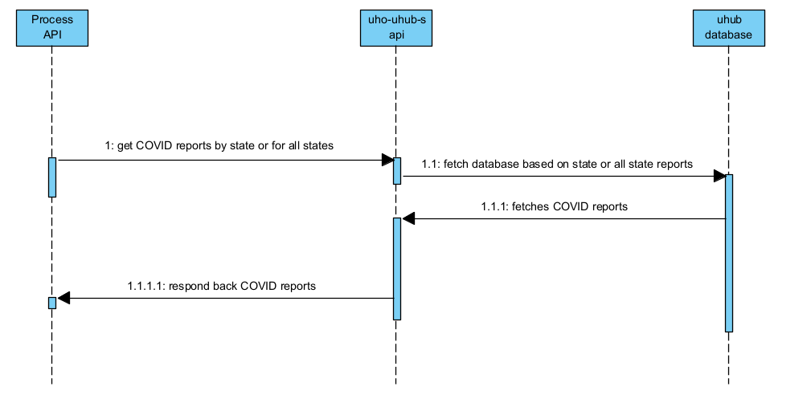

1. The process API’s consumes uho-uhub-sapi.
   1. The uho-uhub-sapi inserts case to database.
      1. The database responds back generated case Id to process API.
         1. The process API responds back registration id to end user.

### Input and Output Definitions of API

**Input:** https://uho-{env}-uhub-sapi/covid/v1/reports?state=texas

**Output: 200, OK**

[

   {

      "state":"texas",

      "report":{

         "total":"46744",

         "positive":"436744",

         "recovered":"433744",

         "death":"300",

         "vaccinated":"7847848"

      }

   }

]

**Input:** https://uho-{env}-uhub-sapi/covid/v1/reports

**Output: 200, OK**

[

   {

      "state":"texas",

      "report":{

         "total":"46744",

         "positive":"436744",

         "recovered":"433744",

         "death":"300",

         "vaccinated":"878484"

      }

   },

   {

      "state":"florida",

      "report":{

         "total":"46744",

         "positive":"436744",

         "recovered":"433744",

         "death":"300",

         "vaccinated":"7847848"

      }

   }

]

### Mapping



### Consumers

|  |  |  |
| --- | --- | --- |
| API Consumer | Description | |
| Experience API’s | | Experience API’s consumes uhub-sapi services to register as case or to fetch COVID cases details. |
| Other UHO applications | | UHO applications can consume uhub-sapi services on requirement since uhub-sapi enabled as utility API in UHO application network. |

### Technical details

|  |  |
| --- | --- |
| API Name | uhub-sapi |
| Business Requirements | As mentioned in integration solution document |
| API Communication Type | REST |
| Interface Pattern | Request/Reply |
| Interface Definitions | RAML API Specification |
| Sample Request | JSON(Section 2.1.1.2) |
| Sample Response | JSON(Section 2.1.1.2) |

### Non Functional

|  |  |
| --- | --- |
| Post Execution Notification Details | Data-Related Failures Handling:  Currently all the errors will be logged into logs with log4j.  Consumer API is responsible to log about error details.  Can be visible in runtime manager.  Technical Errors Handling:  Currently all the errors will be logged into logs with log4j.  Consumer API is responsible to log about error details.  Can be visible in runtime manager. |
| Process Log Audit Details | Audit & Logging:  Created Logs for the following   * Request message at entry point * Request message at system call entry point * Request message at system call entry point * Request completed |

### Error Handling

|  |  |  |
| --- | --- | --- |
| No. | Type of Exception | Exception Handling |
| 1 | Any technical issue | * API shall respond corresponding response message. * API will record the error in logs. * Runtime manager notifications will be configured - TBD * Application Administrative team will be notified using an email notification service- TBD |

### Integration test cases

| **Description** | **Result** |
| --- | --- |
| Successful cases | 200 - Success |
| System connectivity failure (Database is down) | 503 - The (upstream) service is temporarily not available |
| Internal server error | 500 – Internal server error |
| API Kit Router errors | Global errors |

### API Endpoint Details

| **Requirement** | **Method** | **Details** |
| --- | --- | --- |
| **Development** | GET | <https://uho-dev-uhub-sapi/covid/v1/>reports |
| **Test** | GET | <https://uho-test-uhub-sapi/covid/v1/>reports |
| **UAT** | GET | <https://uho-uat-uhub-sapi/covid/v1/>cases/reports |
| **Production** | GET | <https://uho-prod-uhub-sapi/covid/v1/>cases/reports |

# API Policies, Access and Network Security - TBD

|  |
| --- |
| Define API policies to be configured / customized |

| **Requirement** | **Details** |
| --- | --- |
| Access to APIs - Authentication | client_id enforcement |
| API Policy | CORS should be enabled |
| Communication over API’s | x-transaction-id |

# Open Issues

|  |  |
| --- | --- |
| **No** | **Open Issues** |
| 1.0 |  |
|  |  |

# Appendix A – Interface details

WSDLs

Exported RAMLs

Tables outlining data design